**Restore .SQL file into Dbever**

**Steps:**

1. Firstly, download payment_gateway.sql file then
2. Create new database named payment2 in postgres and connect it into dbever.
3. After creating the database, restore .sql file in payment2 database as from script,

It is impossible to restore from tool because it is in sql file so following the steps:

* Create database payment2

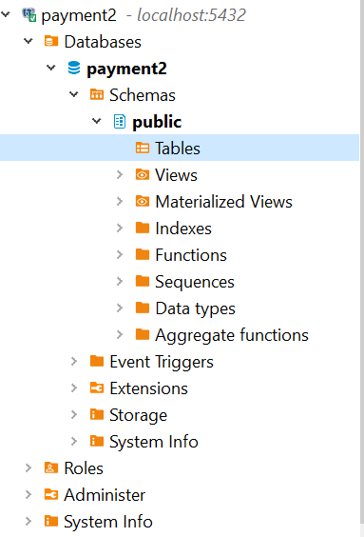

* Go to downloads then open cmd prompt

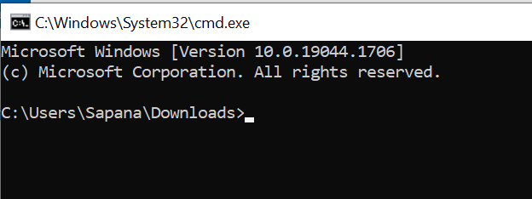

* Then type psql –U postgres –d dbname < filename.sql



* Open dbever then look at database payment2 table:

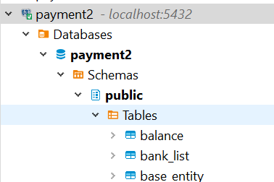

payment_gateway.sql file has been successfully restores.